**PROJECT-NAME: Make My trip - India**

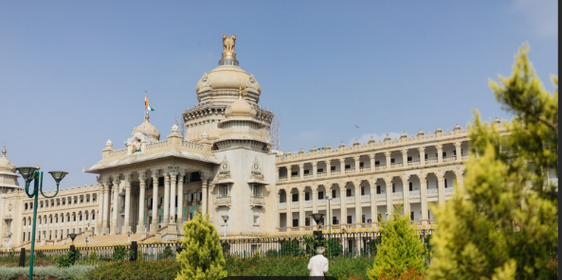 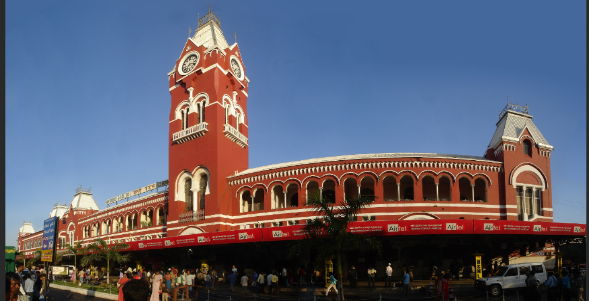

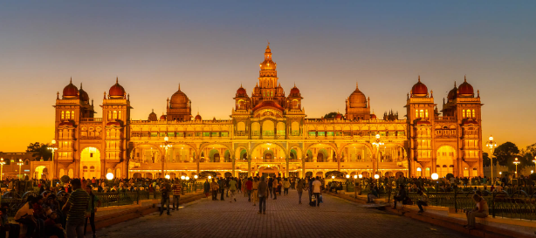

**\*OVERVIEW:** MakeMyTrip is an Indian online travel company, Created to empower the Indian traveler with instant booking and comprehensive choices.

This company is founded in the year 2022 by Sharmila Balanand, and the company begins its journey in India travel market from September 2022.

1. **HOME PAGE:**  Will have,

LOGO 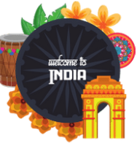, SEARCH BAR, SLIDERS WITH ARROWS - (IMAGES), DEALS – List, Most Visited Destinations - (IMAGES), FOOTER – ( CONTACT US , HELPLINES , BRIEF DESCRIPTION ABOUT THE COMPANY , SOCIAL-MEDIA HANDLE ICONS )

1. **REGISTRATION FORM:** Consists of..

E-MAIL ADDRESS, D.O.B , TRAVEL PREFERENCE

**3. MAIN PAGE:** Consists of

Mode Of Travel ,Hotel Bookings, Rates , Discount Available , Charges, Destination Selection, Day and Date of Travel, Availability of Seats and Rooms, Sesional Rates, Rating, Sort By Price, Sort by Destination, Sort by type of Rooms.

IMAGES OF THE Destination WITH DETAILS LIKE - Rate , Hotel Names , PRICE , Discount ( If Any )

On Clicking the Image – Destination details, along with Package Rates, Hotels (Rooms), Places to Visit will apper.

1. **Payment Page:**

Address Selection. Payment Method – Phonepay, Google Pay, Cash, Card (Credit/Debit)

Goals:

Create a Navigation bar with all the elements:

Logo

Home Page

Packages

Gallery

Review

Contact

Languages used:(Other languages will be used further on)

HTML

CSS